Topic as per syllabus | As per Text Book
Multithreaded Programming: Overview, Multi-core Programming,  Multithreading Models, Implicit Threading, Threading Issues. | Chapter 4 Threads  4.1 Overview  4.2 Multicore Programming  4.3 Multithreading Models  4.5 Implicit Threading  4.6 Threading Issues
Process Scheduling: Basic concepts, Scheduling Criteria, Scheduling  Algorithms. Thread Scheduling, Multiple-Processor Scheduling, Real-Time  CPU Scheduling | Chapter 6 CPU Scheduling  6.1 Basic Concepts 261  6.2 Scheduling Criteria 265  6.3 Scheduling Algorithms 266  6.4 Thread Scheduling 277  6.5 Multiple-Processor Scheduling 278  6.6 Real-Time CPU Scheduling 283

  - Introduction
    - CPU-I/O Burst Cycle
    - CPU Scheduler
    - Preemptive Scheduling
    - Dispatcher
  - Scheduling Criteria
  - Scheduling Algorithms
    - First-Come, First-Served Scheduling
    - Shortest-Job-First Scheduling
    - Priority Scheduling
    - Round-Robin Scheduling
    - Multilevel Queue Scheduling
    - Multilevel Feedback-Queue Scheduling

Introduction:

In a single-processor system, only one process can execute at any given time, while other processes must wait until the CPU is available again. The primary goal of multiprogramming is to ensure that the CPU is continuously utilized, minimizing idle time. The basic idea is straightforward: a process runs until it must wait, usually for an

I/O operation to complete. Without multiprogramming, the CPU would remain idle during this waiting period, resulting in wasted resources. However, with multiprogramming, multiple processes are loaded into memory, and when one process is blocked, the CPU is assigned to another. This cycle ensures that the CPU is always in use. Scheduling, which dictates how the CPU is allocated, is a fundamental function of the operating system and is crucial for managing resources efficiently.

CPU-I/O Burst Cycle
The success of CPU scheduling relies on a key observation about process behavior: process execution alternates between CPU execution and I/O waiting. Each process follows a cycle, beginning with a CPU burst, followed by an I/O burst, then another CPU burst, and so on, until the final CPU burst ends with a system request to terminate (Figure 6.1). The lengths of CPU bursts have been extensively studied, and although they can vary widely between processes and systems, their distribution often follows an exponential or hyperexponential pattern. This means that there are typically many short CPU bursts and fewer long ones. I/O-bound programs tend to have many short CPU bursts, while CPU-bound programs usually have longer CPU bursts.
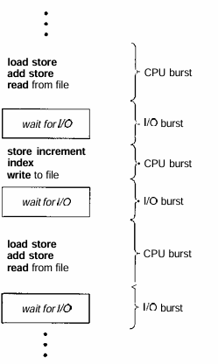

Figure 6.1 Alternating sequence of CPU and I/O bursts.

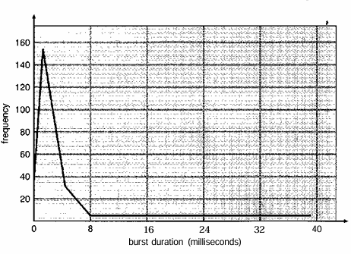
Figure 6.2 Histogram of CPU-burst durations.
A program may have a mix of short and a few long CPU bursts. This distribution is crucial when selecting the most suitable CPU-scheduling algorithm.

CPU Scheduler
When the CPU becomes idle, the operating system must choose one of the processes from the ready queue to execute. This decision is made by the short-term scheduler (or CPU scheduler), which selects a process from those in memory that are ready to run and assigns the CPU to that process.
The ready queue doesn't have to follow a first-in, first-out (FIFO) structure. Depending on the scheduling algorithm used, the ready queue can be implemented as a FIFO queue, priority queue, tree, or an unordered linked list. Conceptually, all the processes in the ready queue are waiting for a chance to use the CPU, and the entries in the queue are typically represented by process control blocks (PCBs) of the processes.

Preemptive Scheduling
CPU scheduling decisions can occur in the following four situations:
      - When a process transitions from the running state to the waiting state, typically due to an I/O request or when waiting for the termination of a child process.
      - When a process transitions from the running state to the ready state, such as when an interrupt occurs.

      - When a process moves from the waiting state to the ready state, for instance, after completing I/O.
      - When a process terminates.
In situations 1 and 4, the scheduling decision is straightforward, as a new process must be selected for execution. However, in situations 2 and 3, there is a choice to be made regarding which process to schedule next.
Scheduling is categorized as either nonpreemptive or preemptive. If scheduling occurs only during situations 1 and 4, it is nonpreemptive, meaning once a process is allocated the CPU, it holds onto it until it either terminates or moves to the waiting state. Nonpreemptive scheduling was used by older versions of Microsoft Windows (3.x) but has since been replaced with preemptive scheduling starting with Windows 95. Preemptive scheduling is also employed by macOS X and modern versions of UNIX. Nonpreemptive scheduling is still useful in environments lacking the hardware necessary for preemptive scheduling.
Preemptive scheduling introduces challenges, particularly concerning access to shared data. For instance, if one process is updating shared data and is preempted, the second process may read inconsistent data. This situation requires mechanisms to ensure data integrity, which is addressed in Chapter 6. Additionally, preemption affects kernel design, particularly when a process is preempted during the execution of system calls. In such cases, operating systems like UNIX ensure consistency by avoiding context switches during critical kernel operations, but this approach can hinder real-time and multiprocessing tasks.
Interrupts, which can occur at any time, further complicate scheduling, as the kernel must handle them promptly. To avoid concurrent access to sensitive code, the system disables interrupts during critical sections and reenables them afterward. These interrupt- disabling sections are typically brief and infrequent but are essential for maintaining system stability.

Dispatcher
Another key component in the CPU scheduling process is the dispatcher. The dispatcher is responsible for transferring control of the CPU to the process selected by the short-term scheduler. This function involves three main tasks:
- Switching context – Saving the state of the currently running process and loading the state of the next process.
- Switching to user mode – Changing the processor from kernel mode to user mode.
- Jumping to the correct location in the user program to resume execution.

The dispatcher must be as fast as possible because it is invoked every time the operating system switches between processes. The time it takes for the dispatcher to perform these tasks is referred to as dispatch latency.

Component | What It Does | Role in Process Execution
Scheduling Algorithm | Defines the rule to select the next process | Example: FCFS, SJF, Round Robin
CPU Scheduler | Selects one process from ready queue using the algorithm | Decides who gets CPU next
Dispatcher | Gives control of CPU to selected process | Performs context switching

Scheduling Criteria:

Different CPU scheduling algorithms come with various properties, and the selection of an algorithm can impact how well the system performs for different types of processes. When choosing an algorithm, it is important to consider several criteria, as each has a significant effect on the algorithm’s effectiveness.
Some key criteria for comparing CPU scheduling algorithms include:
- CPU Utilization: The goal is to keep the CPU as busy as possible, ideally between 40% for a lightly loaded system and 90% for a heavily loaded system.
- Throughput: This measures how much work the system completes, i.e., the number of processes completed per unit of time. For example, this could range from one process per hour for long-running processes to ten processes per second for short tasks.
- Turnaround Time: The total time from when a process is submitted to when it is completed, including waiting, CPU execution, and I/O times.
- Waiting Time: The time a process spends in the ready queue waiting to be executed, excluding time spent executing or performing I/O.
- Response Time: In interactive systems, this is the time from submitting a request to receiving the first response. It focuses on how quickly the system can begin providing output, rather than completing the task.
Ideally, we want to maximize CPU utilization and throughput while minimizing turnaround time, waiting time, and response time. While the average is often optimized, in some cases, it is better to minimize the maximum or minimum values, such as ensuring a good maximum response time for all users. For interactive systems, it may be more important to minimize the variance in response times rather than the average, creating a more predictable user experience.

Scheduling Algorithms:

CPU scheduling focuses on deciding which process in the ready queue should be allocated the CPU. To address this challenge, various CPU scheduling algorithms have been developed, each employing distinct strategies and objectives. This section examines these algorithms and their key characteristics.

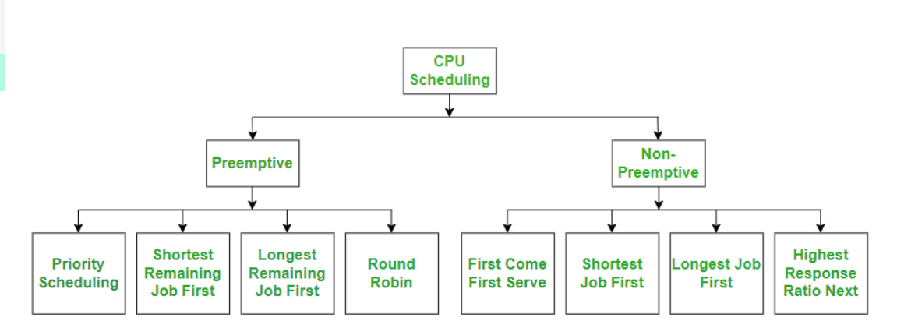

  - Scheduling Algorithms
    - First-Come, First-Served Scheduling
    - Shortest-Job-First Scheduling
    - Priority Scheduling
    - Round-Robin Scheduling
    - Multilevel Queue Scheduling
    - Multilevel Feedback-Queue Scheduling

Important Scheduling Terminologies:
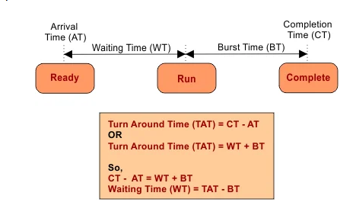
CPU Time: It is the time taken by CPU to execute the process.
I/O Time: It is the time taken by process to execute I/O operations.
Burst Time: It can also be referred as Execution Time. It is the time taken by process to complete its execution on CPU.
Arrival Time: It is the time when a process enters in ready state or is ready for execution.
Exit Time/Completion Time: It is the time when system complete its execution and exits from the system.
Response Time: It is the time taken when the process is in the ready state and gets the CPU for first time.
Waiting Time: It is the total time passed waiting for CPU, in ready state.
Note: There is a difference between Response time and Waiting time. Response time is the time needed between ready state and getting the CPU first time. While Waiting time is time taken by process in ready state.
Turnaround Time: It is the total time taken by a process from coming into ready state till the complete execution. It can be calculated as-
Turnaround Time = Burst Time + Waiting Time
It can also be calculated as: Turnaround Time = Exit Time — Arrival Time
Throughput: It can be defined as the number of processes executed by CPU in a given amount of time.

First-Come, First-Served Scheduling
First-Come, First-Served (FCFS) scheduling is the simplest CPU scheduling algorithm, where processes are executed in the order they arrive in the ready queue. It is a non- preemptive scheduling method, meaning that once a process starts execution, it runs to completion without interruption.

Features of FCFS Scheduling
- Execution Order: Processes are scheduled based on their arrival time.
- Non-Preemptive: A running process cannot be interrupted by another process.
- Implementation: The ready queue is organized as a FIFO (First-In, First-Out) queue.
- Fair but Inefficient: Every process gets a turn, but longer processes can delay shorter ones.

Example of FCFS Scheduling Process Details:
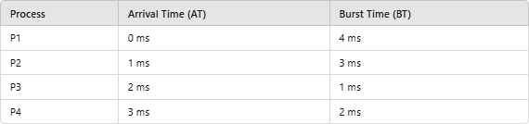

Step 1: Create the Execution Order
- Based on arrival time: P1 → P2 → P3 → P4.

Step 2: Draw the Gantt Chart
A Gantt chart illustrates the execution sequence and completion times of the processes:

P1 | P2 | P3 | P4

0 4 7 8 10

Step 3: Calculate Metrics
- Completion Time (CT): Time when a process finishes execution.
o P1: 0 + 4 = 4 ms
o P2: 4 + 3 = 7 ms

o P3: 7 + 1 = 8 ms
o P4: 8 + 2 = 10 ms

Turnaround Time (TAT):
TAT=CT−AT
o P1: 4 - 0 = 4 ms
o P2: 7 - 1 = 6 ms
o P3: 8 - 2 = 6 ms
o P4: 10 - 3 = 7 ms
- Waiting Time (WT): WT=TAT−BT
  - P1: 4 - 4 = 0 ms
  - P2: 6 - 3 = 3 ms
  - P3: 6 - 1 = 5 ms
  - P4: 7 - 2 = 5 ms

Table:
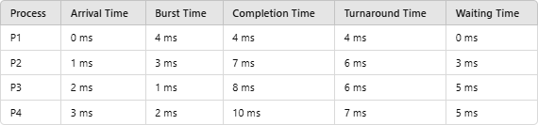
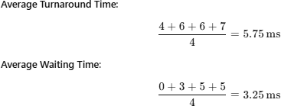

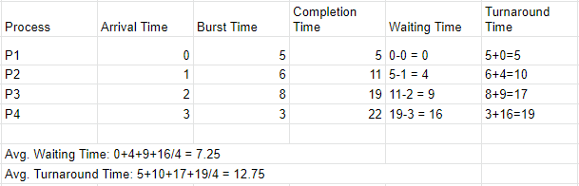

Gantt Chart:
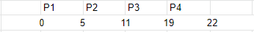
Gantt Chart for FCFS Scheduling

Advantages of FCFS
- Simplicity: Easy to understand and implement.
- Fairness: Every process gets executed in the order of arrival.

Disadvantages of FCFS
- Convoy Effect: A long process can block the queue, causing delays for shorter processes.
- Poor Utilization: Longer waiting times for processes arriving later.
- Not Suitable for Interactive Systems: Response times can be too high for real-time or time-sharing systems.
FCFS is a foundational CPU scheduling algorithm suitable for batch systems but is often replaced by more efficient algorithms like Shortest Job Next (SJN) or Round Robin (RR) in modern operating systems.

Algorithm: First Come First Serve (FCFS)
- Start
- Read number of processes n
- For each process:
  - Read Arrival Time (AT)
  - Read Burst Time (BT)
- Set:
  - WT[0] = 0
  - TAT[0] = BT[0]
- For each process from 1 to n-1:
  - Calculate Waiting Time
WT[i] = WT[i-1] + BT[i-1] - AT[i]
  - If WT[i] < 0, set WT[i] = 0
  - Calculate Turnaround Time
TAT[i] = WT[i] + BT[i]
- Calculate:
  - Average Waiting Time
  - Average Turnaround Time
- Display results
- Stop

TAT = CT − AT
WT = TAT − BT
WT[i] = Previous CT − AT[i]

Algorithm: First Come First Serve (FCFS)
- Start
- Read number of processes n
- For each process:
  - Read Arrival Time (AT)
  - Read Burst Time (BT)
  - Assign Process ID
- Sort all processes in ascending order of Arrival Time
- Set current_time = 0
- For each process from 0 to n-1:
  - If current_time < AT[i]
    - Set current_time = AT[i]
(CPU is idle until process arrives)
  - Calculate Completion Time:
CT[i] = current_time + BT[i]
  - Calculate Turnaround Time:
TAT[i] = CT[i] - AT[i]
  - Calculate Waiting Time:
WT[i] = TAT[i] - BT[i]
  - Update current time:
current_time = CT[i]
- Calculate:
  - Average Waiting Time
Average WT = (Sum of WT) / n
  - Average Turnaround Time
Average TAT = (Sum of TAT) / n
- Display results:
  - Process ID
  - Arrival Time
  - Burst Time
  - Completion Time
  - Waiting Time
  - Turnaround Time
  - Averages
- Stop

Scenario 1: Processes with Same Arrival Time
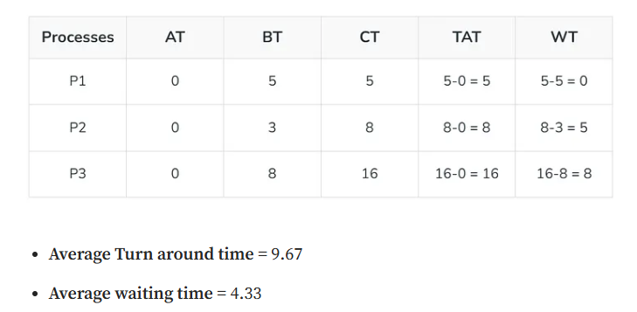

Scenario 2: Processes with Different Arrival Times

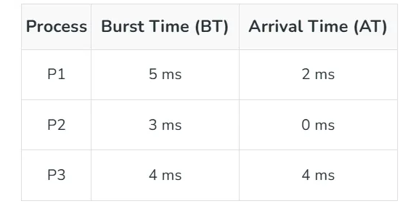

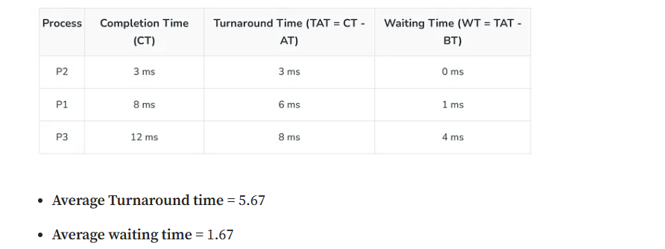

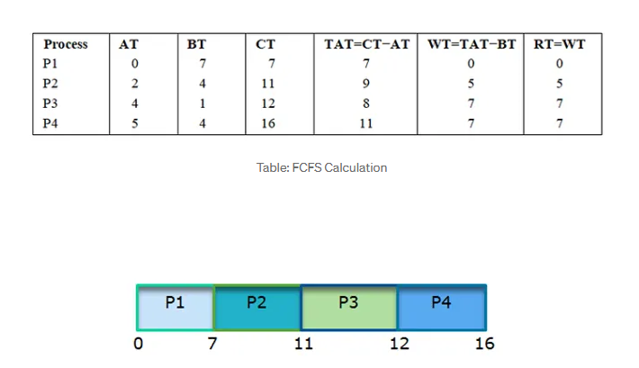

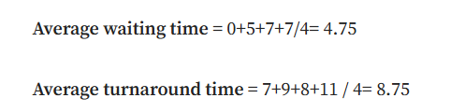

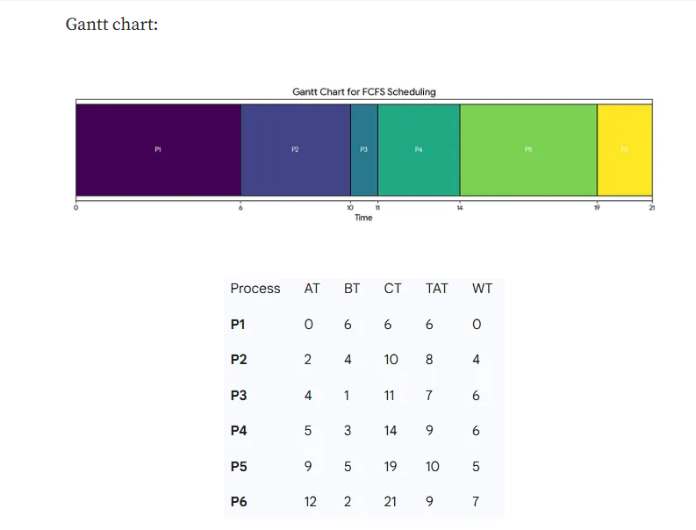

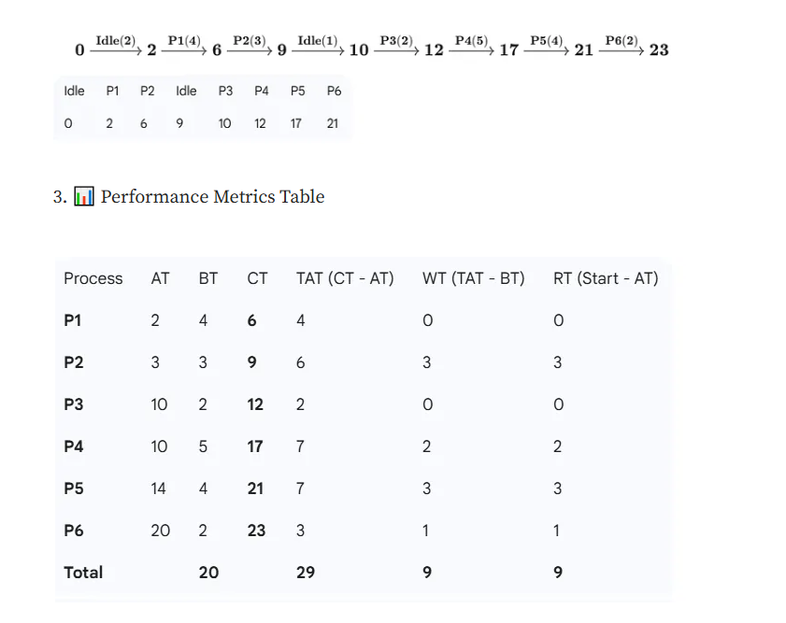

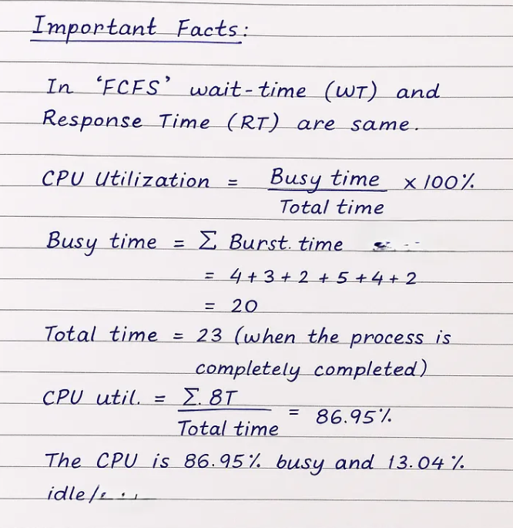

Shortest-Job-First Scheduling
Shortest-Job-First (SJF) is a CPU scheduling algorithm that selects the process with the smallest burst time for execution. It minimizes waiting time and is widely regarded as an optimal scheduling technique for reducing average waiting and turnaround times.
SJF can be implemented in two forms:
- Non-Preemptive SJF: Once a process starts, it runs to completion.
- Preemptive SJF (also known as Shortest Remaining Time First, SRTF): If a new process arrives with a shorter burst time than the remaining time of the current process, the CPU is preempted.

Characteristics of SJF
- Priority: Shorter burst time processes are given priority.
- Optimality: It minimizes the average waiting time and turnaround time.
- Complexity: Requires knowledge of burst times in advance, which is difficult in real- world scenarios.

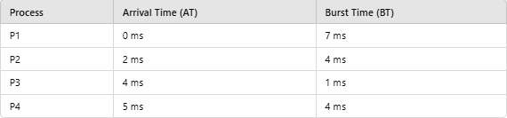
Example of Non-Preemptive SJF Scheduling Given Processes:

Step 1: Arrange Processes by Arrival Time
Initially, only P1 is available. When P2, P3, and P4 arrive, the process with the shortest burst time is selected.

Step 2: Execute Processes
- P1 executes first (no other process available at 0 ms).
- At 7 ms, P2, P3, and P4 are ready. P3 (1 ms) executes next.
- After P3, the next shortest burst time is P2 (4 ms).
- Finally, P4 executes.
Gantt Chart

P1 | P3 | P2 | P4

0 7 8 12 16
Step 3: Calculate Metrics
- Completion Time (CT):
o P1: 0 + 7 = 7 ms
o P3: 7 + 1 = 8 ms
o P2: 8 + 4 = 12 ms
o P4: 12 + 4 = 16 ms
  - Turnaround Time (TAT): TAT=CT−
  - P1: 7 - 0 = 7 ms
  - P2: 12 - 2 = 10 ms
  - P3: 8 - 4 = 4 ms
  - P4: 16 - 5 = 11 ms

Waiting Time (WT):
WT=TAT−BT
  - P1: 7 - 7 = 0 ms
  - P2: 10 - 4 = 6 ms
  - P3: 4 - 1 = 3 ms
  - P4: 11 - 4 = 7 ms

Table:
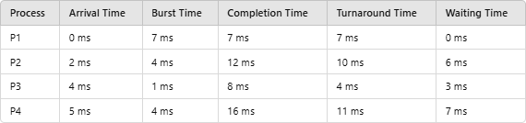
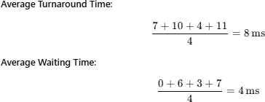

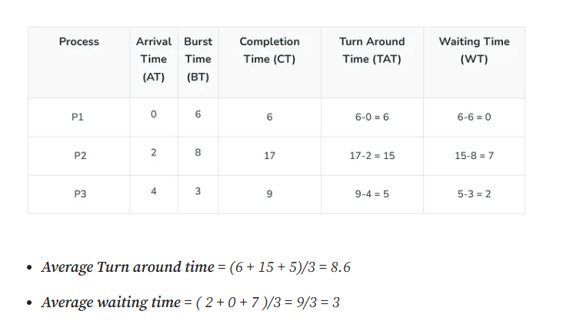

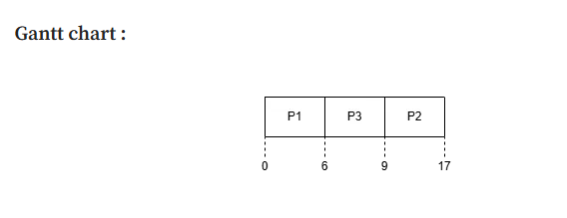
If arrival time (AT) is not provided in the question, then there is an automatic rule:

✅ Assume all Arrival Times = 0

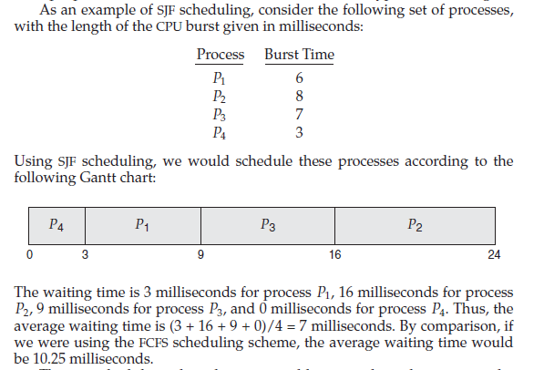

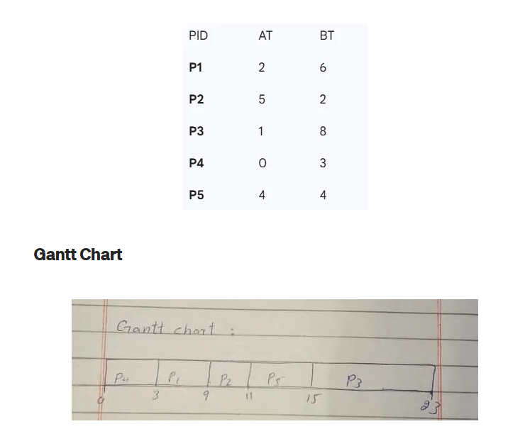

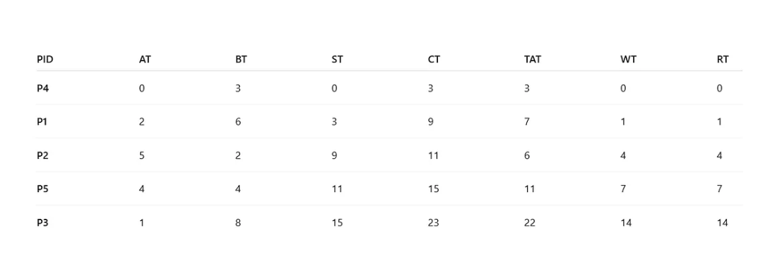

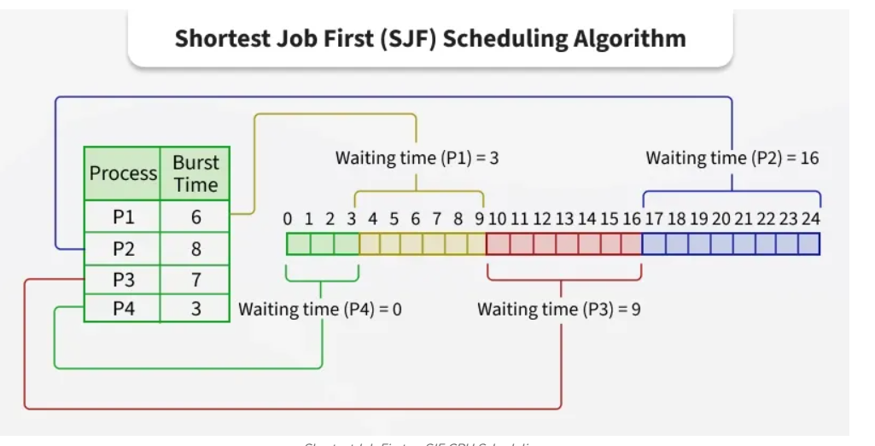

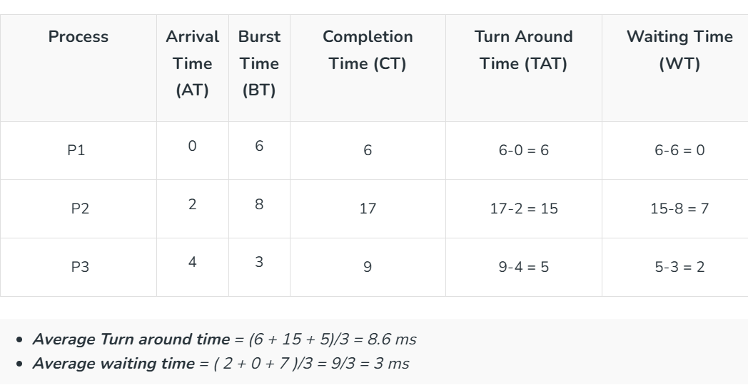

Algorithm: Shortest Job First (SJF – Non-Preemptive)
- Start
- Read number of processes n
- For each process:
  - Read Arrival Time (AT)
  - Read Burst Time (BT)
  - Assign Process ID
- Sort all processes in ascending order of Burst Time (BT)
(If two burst times are equal, maintain arrival order)
- Set:
  - WT[0] = 0
- For each process from 1 to n-1:
  - Calculate Waiting Time:
WT[i] = WT[i-1] + BT[i-1] - AT[i]
  - If WT[i] < 0
WT[i] = 0
- For each process from 0 to n-1:
  - Calculate Turnaround Time:
TAT[i] = BT[i] + WT[i]
- Calculate:
  - Average Waiting Time
Average WT = (Sum of WT) / n
  - Average Turnaround Time
Average TAT = (Sum of TAT) / n

Algorithm: Improved Shortest Job First (SJF – Non-Preemptive)
- Start
- Read number of processes n
- For each process:
  - Read Arrival Time (AT)
  - Read Burst Time (BT)
  - Assign Process ID
  - Mark process as not completed
- Set:
  - current_time = 0
  - completed = 0
- While (completed < n):
  - Among all processes where:
AT[i] ≤ current_time
AND process is not completed
select the process with minimum Burst Time (BT).
  - If no such process is found:
current_time = current_time + 1
(CPU is idle)
  - Else:
    - Calculate Completion Time:
CT[i] = current_time + BT[i]
    - Calculate Turnaround Time:
TAT[i] = CT[i] - AT[i]
    - Calculate Waiting Time:
WT[i] = TAT[i] - BT[i]
    - Mark process as completed
    - Update current time:
current_time = CT[i]
    - Increment completed count
- Calculate:
  - Average Waiting Time
Average WT = (Sum of WT) / n
  - Average Turnaround Time
Average TAT = (Sum of TAT) / n
- Display results:
  - Process ID
  - Arrival Time
  - Burst Time
  - Completion Time
  - Waiting Time
  - Turnaround Time
  - Averages
- Stop

Advantages of SJF
- Optimal for Waiting Time: SJF minimizes the average waiting time.
- Efficient: Reduces turnaround time for shorter processes.

Disadvantages of SJF
- Starvation: Longer processes may experience indefinite delays.
- Uncertainty: Exact burst times are often difficult to predict.
- Not Suitable for Time-Sharing: Non-preemptive SJF cannot handle interactive systems effectively.
SJF scheduling is a highly efficient algorithm for batch systems where burst times are predictable. However, its practical implementation is limited due to the challenges of estimating burst times and potential starvation of longer processes. To overcome these drawbacks, Shortest Remaining Time First (SRTF) or other dynamic scheduling methods are often preferred in modern systems.

Shortest Remaining Time First Scheduling Algorithm

The pre-emptive version of Shortest Job First (SJF) scheduling is called Shortest Remaining Time First (SRTF). In SRTF, the process with the least time left to finish is selected to run. The running process continues until it finishes or a new process with a shorter remaining time arrives, ensuring the fastest finishing process always gets priority.

The pre-emptive version of Shortest Job First (SJF) scheduling is called Shortest Remaining Time First (SRTF). In SRTF, the process with the least time left to finish is selected to run. The running process continues until it finishes or a new process with a shorter remaining time arrives, ensuring the fastest finishing process always gets priority.

Example of SJF Algorithm:
Scenario 1: Processes with Same Arrival Time
Example: Consider the following table of arrival time and burst time for three processes P1, P2 and P3.

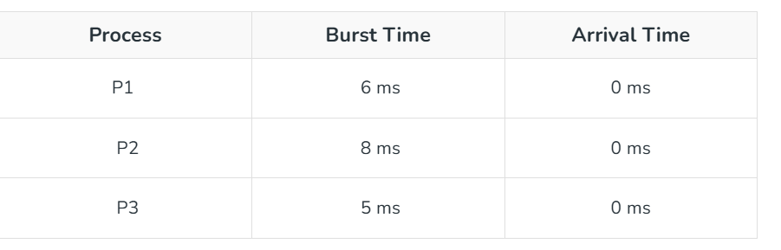

- Time 0-5 (P3): P3 runs for 5 ms (total time left: 0 ms) as it has shortest remaining time left.
- Time 5-11 (P1): P1 runs for 6 ms (total time left: 0 ms) as it has shortest remaining time left.
- Time 11-19 (P2): P2 runs for 8 ms (total time left: 0 ms) as it has shortest remaining time left.

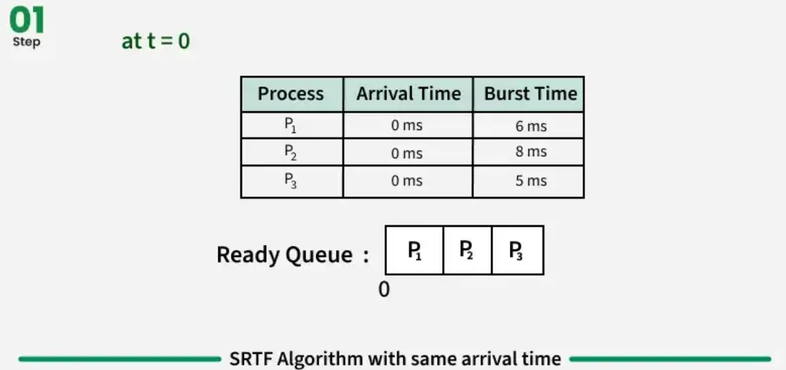

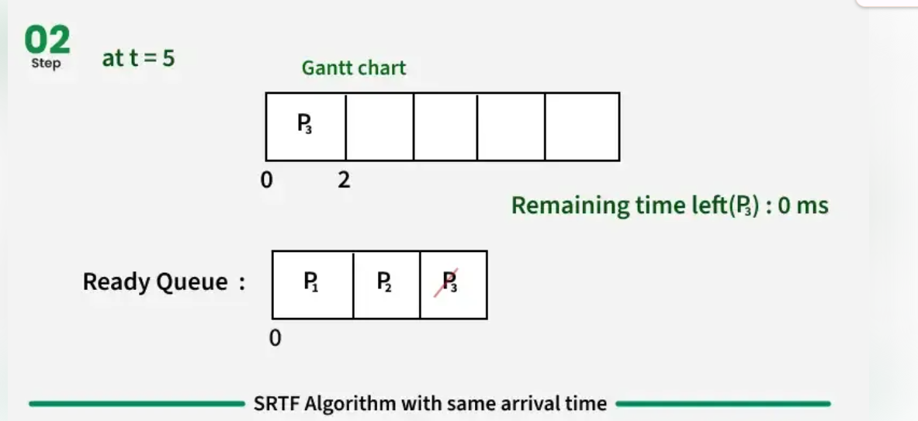

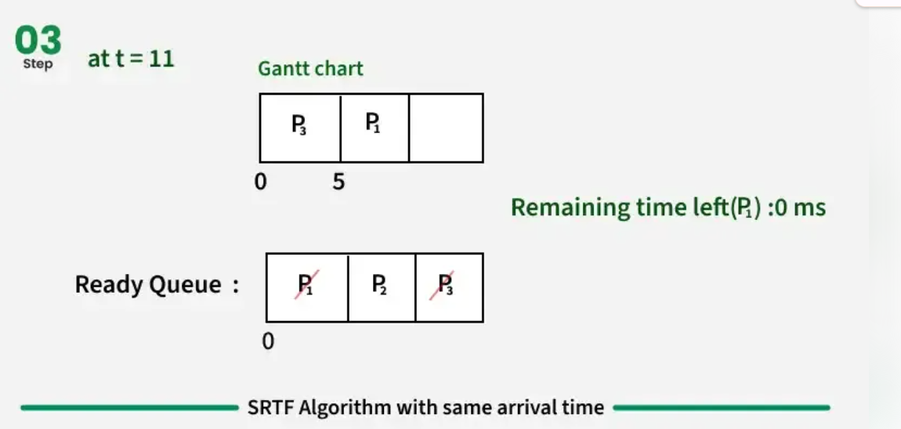

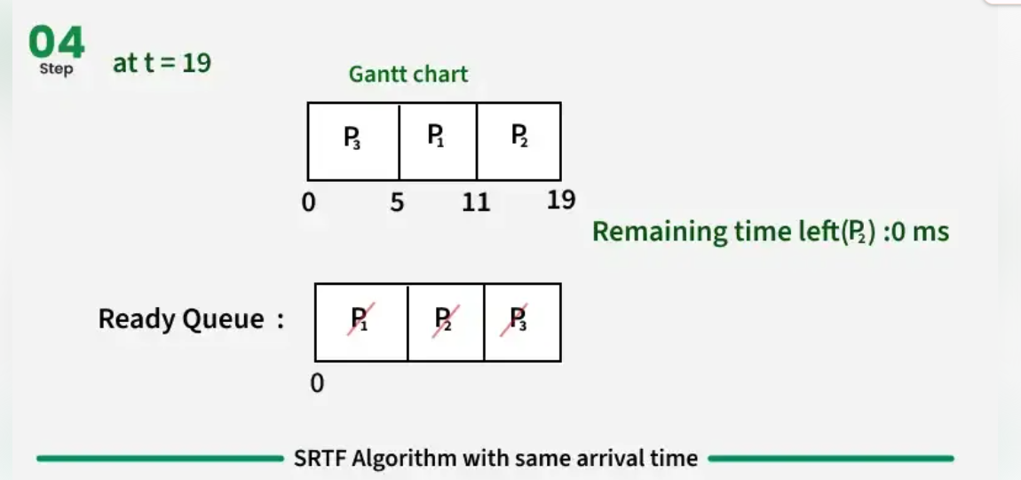

Scenario 2: Processes with Different Arrival Times
Consider the following table of arrival time and burst time for three processes P1, P2 and P3.

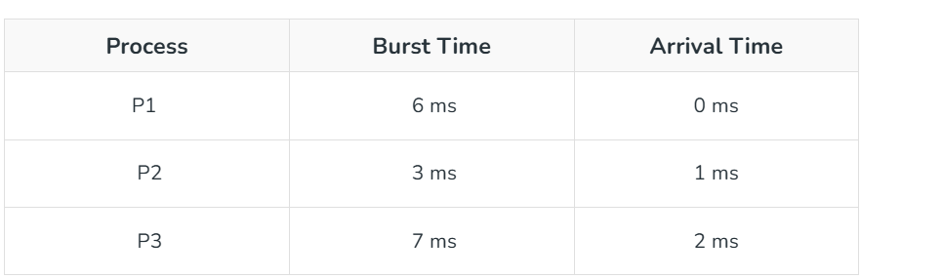

Step-by-Step Execution:
- Time 0-1 (P1): P1 runs for 1 ms (total time left: 5 ms) as it has shortest remaining time left.
- Time 1-4 (P2): P2 runs for 3 ms (total time left: 0 ms) as it has shortest remaining time left among P1 and P2.
- Time 4-9 (P1): P1 runs for 5 ms (total time left: 0 ms) as it has shortest remaining time left among P1 and P3.
- Time 9-16 (P3): P3 runs for 7 ms (total time left: 0 ms) as it has shortest remaining time left.

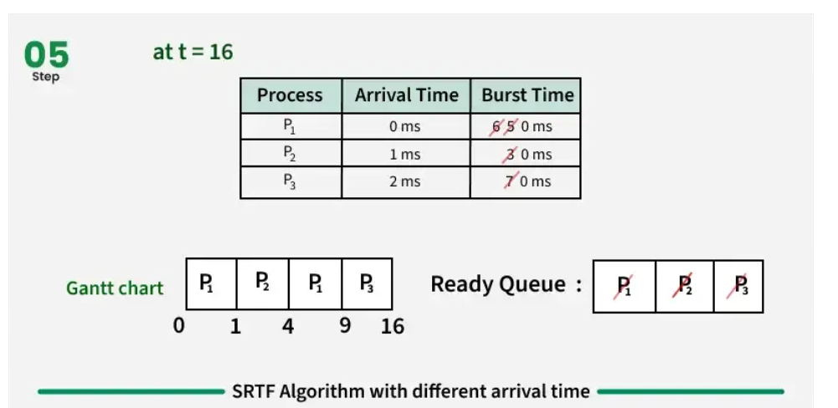

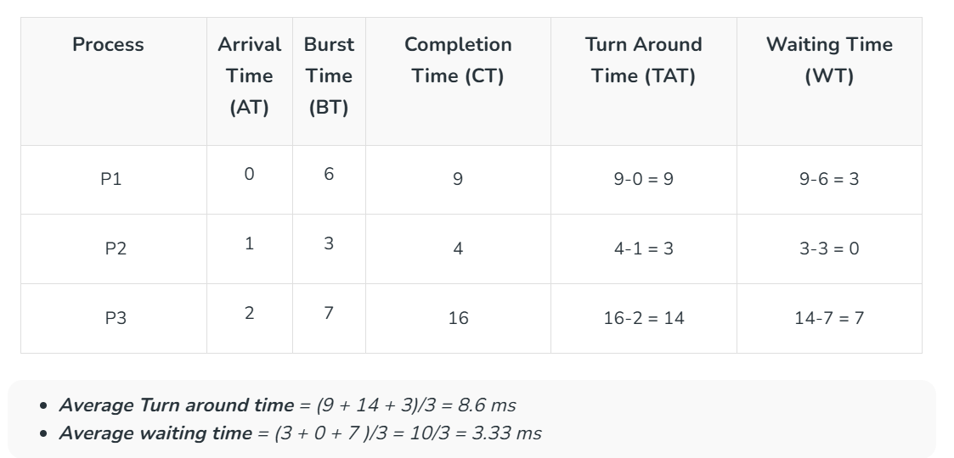

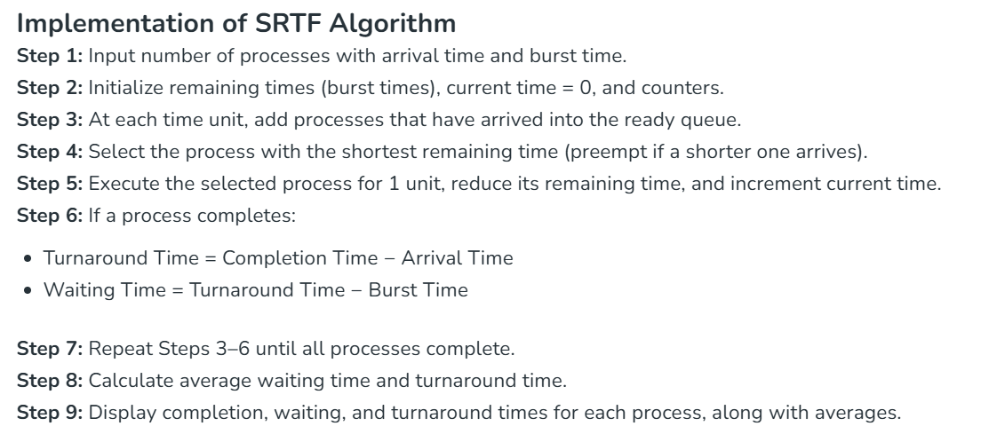

Priority Scheduling
Priority Scheduling is a CPU scheduling algorithm that assigns a priority level to each process. The process with the highest priority is executed first. Priority can be determined based on various factors such as process type, resource requirements, or importance.
The algorithm can be implemented in two ways:
- Preemptive Priority Scheduling: If a new process arrives with a higher priority than the currently executing process, it preempts the CPU.
- Non-Preemptive Priority Scheduling: The currently executing process completes its execution before the CPU is allocated to a higher-priority process

Characteristics of Priority Scheduling
- Priority-Based: Processes with higher priority are executed before lower-priority processes.
- Preemptive and Non-Preemptive Variants: Offers flexibility in implementation.
- Starvation: Lower-priority processes may wait indefinitely if higher-priority processes continuously arrive.
- Aging: A technique to prevent starvation by gradually increasing the priority of waiting processes.

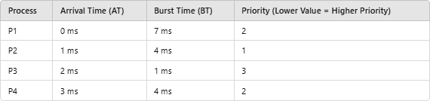
Example of Non-Preemptive Priority Scheduling Given Processes:
Step 1: Arrange by Priority
  - Process with the lowest priority value executes first.
  - If multiple processes have the same priority, the tie is resolved using arrival time.

Step 2: Execute Processes
- P1 starts execution at time 0.
- At 1 ms, P2 arrives with a higher priority and executes next after P1.

- P3 and P4 execute according to priority order.

Gantt Chart

P1 | P2 | P4 | P3

0 7 11 15 16

Step 3: Calculate Metrics
- Completion Time (CT):
  - P1: 7 ms
  - P2: 11 ms
  - P3: 16 ms
  - P4: 15 ms

Turnaround Time (TAT):
TAT=CT−AT
  - P1: 7 - 0 = 7 ms
  - P2: 11 - 1 = 10 ms
  - P3: 16 - 2 = 14 ms
  - P4: 15 - 3 = 12 ms

Waiting Time (WT):
WT=TAT−BT
  - P1: 7 - 7 = 0 ms
  - P2: 10 - 4 = 6 ms
  - P3: 14 - 1 = 13 ms
  - P4: 12 - 4 = 8 ms

Table:
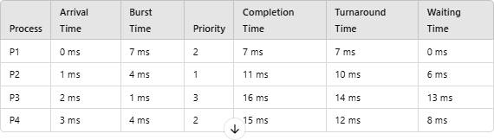
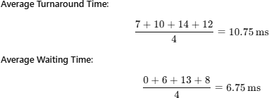

Advantages of Priority Scheduling
- Flexibility: Allows differentiation between processes based on their importance.
- Efficient Resource Allocation: Critical tasks can be executed sooner.

Disadvantages of Priority Scheduling
- Starvation: Low-priority processes may never execute if higher-priority processes keep arriving.
- Complexity: Determining and assigning accurate priorities can be challenging.
- Unfairness: May favor specific processes excessively.

Solution to Starvation: Aging
Aging is a technique that gradually increases the priority of processes waiting in the ready queue for a long time. This ensures that lower-priority processes eventually get executed.
Priority Scheduling is a versatile algorithm, particularly suitable for real-time systems and scenarios where certain processes must be prioritized. However, to avoid starvation and ensure fairness, mechanisms like aging are essential.

Round-Robin Scheduling
Round-Robin (RR) is a CPU scheduling algorithm designed for time-sharing systems. In this method, each process is assigned a fixed time slice or time quantum. The CPU cycles through

all processes in the ready queue, executing each process for a maximum of one time quantum before moving to the next process. If a process does not finish within its assigned time quantum, it is placed at the end of the queue.

Characteristics of Round-Robin Scheduling
      - Time Quantum: Each process gets an equal time slice for execution.
      - Preemptive: If a process does not finish within its time quantum, it is preempted and re- queued.
      - Fairness: All processes are treated equally, preventing starvation.
      - Efficient for Time-Sharing: Ideal for interactive and real-time systems due to quick response times.

How Round-Robin Works
- Ready Queue Management: The processes are maintained in a circular queue.
- CPU Allocation: Each process gets the CPU for a duration up to the time quantum.
- Preemption: If a process's burst time exceeds the time quantum, the remaining time is added back to the queue.

Example of Round-Robin Scheduling Given Processes:
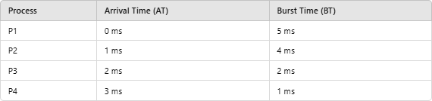

Time Quantum: 2 ms

Step 1: Create the Execution Order
- Start with the first process in the ready queue.
- Allocate the CPU for a maximum of the time quantum.
- If a process completes within its time quantum, it exits the queue.
- If not, it re-enters the queue with its remaining burst time.

Gantt Chart
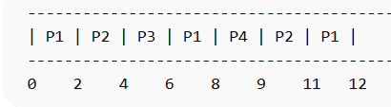
Process | AT | BT | CT | TAT (CT-AT) | WT (TAT-BT)
P1 | 0 | 5 | 12 | 12 | 7
P2 | 1 | 4 | 11 | 10 | 6
P3 | 2 | 2 | 6 | 4 | 2
P4 | 3 | 1 | 9 | 6 | 5

Time | Running Process | Ready Queue (after update)
0–2 | P1 | [P2, P3, P1]
2–4 | P2 | [P3, P1, P4, P2]
4–6 | P3 | [P1, P4, P2]
6–8 | P1 | [P4, P2, P1]
8–9 | P4 | [P2, P1]
9–11 | P2 | [P1]
11–12 | P1 | [ ]

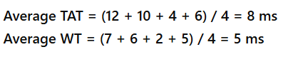
If a process is preempted and a new process arrives at the same time, the newly arrived process is placed ahead of the preempted process in the ready queue, since arrival is handled before reinserting the preempted process

Advantages of Round-Robin Scheduling
- Fairness: All processes are given equal time.
- Prevention of Starvation: No process waits indefinitely for the CPU.
- Interactive Systems: Ideal for time-sharing systems due to regular context switches.

Disadvantages of Round-Robin Scheduling
- Overhead: Frequent context switching can increase CPU overhead.
- Response Time Dependence: Performance depends on the size of the time quantum.
  - A small quantum increases context switches and overhead.
  - A large quantum reduces responsiveness and can mimic First-Come, First- Served (FCFS).
Round-Robin scheduling is a widely used algorithm, particularly for interactive and time-sharing systems. It balances fairness and responsiveness but requires careful selection of the time quantum to optimize performance.

Multilevel Queue Scheduling
Multilevel Queue Scheduling is a CPU scheduling algorithm where the ready queue is divided into multiple distinct queues. Each queue is designed for a specific category of processes, such as system processes, interactive processes, or batch processes. Each queue can have its own scheduling algorithm, and a priority is assigned to decide the order of queue execution.

Characteristics of Multilevel Queue Scheduling
      - Queue Classification: Processes are categorized into different queues based on their type (e.g., system, user, background).
      - Fixed Priority: Queues are executed based on priority. Higher-priority queues preempt lower-priority queues.

      - Separate Scheduling: Each queue can use a different scheduling algorithm (e.g., Round- Robin, FCFS).
      - Non-Preemptive or Preemptive: Execution can either be non-preemptive (lower- priority queues wait until higher-priority queues finish) or preemptive.

Structure of Multilevel Queue Scheduling
        - System Queue: Reserved for system-critical processes.
        - Interactive Queue: For processes requiring user interaction.
        - Batch Queue: For background or long-running processes.

Example of Multilevel Queue Scheduling Given Queues:
- System Queue (Priority 1): Uses Round-Robin Scheduling. With Q = 2
- Interactive Queue (Priority 2): Uses First-Come, First-Served Scheduling.
- Batch Queue (Priority 3): Uses First-Come, First-Served Scheduling.
Ready Queue is divided into separate queues for each class of processes. For example, let us take three different types of processes System processes, Interactive processes, and Batch Processes. All three processes have their own queue. Now, look at the below figure.

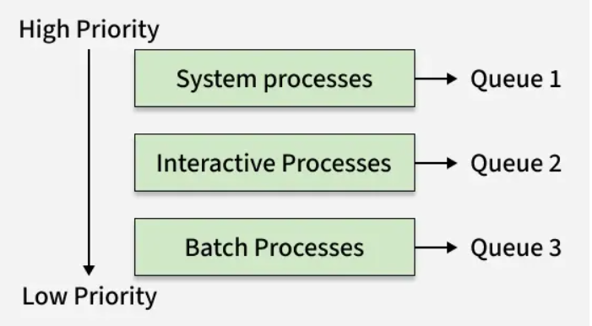

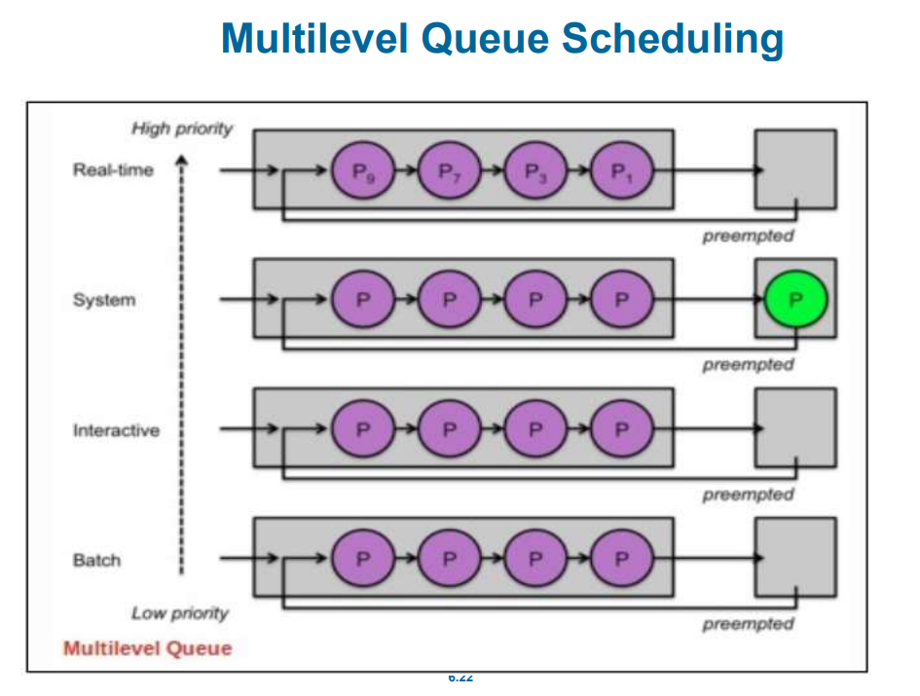

When processes can be readily categorized, then multiple separate queues can be established, each implementing whatever scheduling algorithm is most appropriate for that type of job, and/or with different parametric adjustments.
- Note that under this algorithm jobs cannot switch from queue to queue - Once they are assigned a queue, that is their queue until they finish.
- Each queue has its own scheduling algorithm for example: foreground – RR
- background – FCFS
- In multilevel queue scheduling, if preemptive priority is used, a newly arrived higher-priority process immediately preempts the currently running lower-priority process. If non-preemptive scheduling is used, the system allows the current process to complete before switching.

Processes:
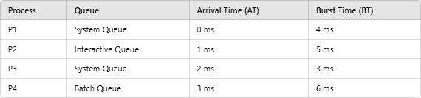
Step 1: Process Execution Based on Queue Priority
- System Queue (Priority 1) executes P1 and P3 using Round-Robin. With Q=2
- After all System Queue processes are completed, the Interactive Queue (Priority 2) executes P2.
- Finally, the Batch Queue (Priority 3) executes P4.

Gantt Chart

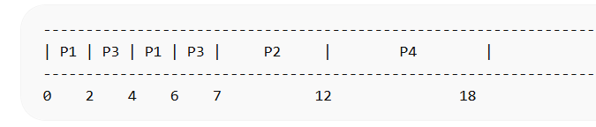

Process | Queue | AT | BT | CT | TAT (CT-AT) | WT (TAT-BT)
P1 | System Queue | 0 | 4 | 6 | 6 | 2
P2 | Interactive Queue | 1 | 5 | 12 | 11 | 6
P3 | System Queue | 2 | 3 | 7 | 5 | 2
P4 | Batch Queue | 3 | 6 | 18 | 15 | 9
• Average Turnaround Time = (6 + 11 + 5 + 15) / 4 = 9.25 ms
• Average Waiting Time = (2 + 6 + 2 + 9) / 4 = 4.75 ms

Advantages of Multilevel Queue Scheduling
- Efficient Process Categorization: Processes are grouped based on their type or importance.
- Flexibility: Different queues can have different scheduling algorithms to suit specific needs.
- Priority Control: High-priority tasks are executed sooner.

Disadvantages of Multilevel Queue Scheduling
- Starvation: Lower-priority queues may experience indefinite delays if higher-priority queues are always occupied.
- Complexity: Managing multiple queues and scheduling rules can be challenging.
- Rigid Classification: Once assigned, a process cannot move between queues.

Solution to Starvation: Aging
To mitigate starvation, the priority of long-waiting processes in lower-priority queues can be increased over time.
Multilevel Queue Scheduling is ideal for systems with diverse process requirements, such as interactive and batch processing systems. While it provides flexibility and prioritization, it requires careful configuration to avoid starvation and inefficiency.

Multilevel Feedback-Queue Scheduling
Multilevel Feedback Queue Scheduling is an advanced CPU scheduling algorithm that allows processes to move between multiple queues based on their behavior and requirements. Unlike Multilevel Queue Scheduling, where processes are permanently assigned to a queue, the feedback mechanism in this algorithm adapts dynamically, promoting or demoting processes among queues based on their execution characteristics.
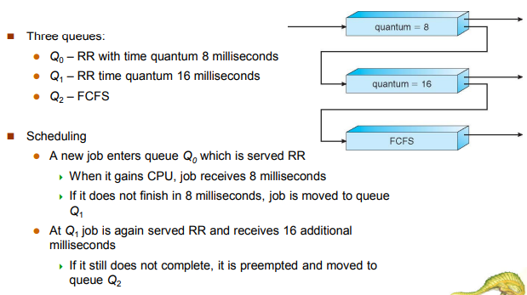

Features of Multilevel Feedback Queue Scheduling
- Multiple Queues: Similar to multilevel queue scheduling, there are multiple queues, each with a specific priority and scheduling algorithm.
- Dynamic Adjustment: Processes can move between queues based on their CPU burst times. Shorter processes are prioritized, while longer ones may be moved to lower- priority queues.
- Aging: This prevents starvation by gradually increasing the priority of processes that have waited too long.
- Preemptive: The scheduler can preempt lower-priority processes if a higher-priority process arrives.

Structure of Multilevel Feedback Queue Scheduling
- Top Queue (Highest Priority): Uses Round-Robin with a small time quantum to handle interactive processes.
- Middle Queue: Uses Round-Robin with a larger time quantum to accommodate processes requiring longer execution.
- Bottom Queue (Lowest Priority): Uses First-Come, First-Served (FCFS) to handle batch or long-running processes.

Rules for Moving Between Queues
- A process starts in the highest-priority queue.
- If a process uses its entire time quantum without completing, it is moved to a lower- priority queue.
- If a process waits too long in a lower-priority queue, it may be promoted to a higher- priority queue (aging).

Example of Multilevel Feedback Queue Scheduling Assume 3 Queues:
- Queue 1 (Priority 1): Round-Robin, Time Quantum = 4 ms
- Queue 2 (Priority 2): Round-Robin, Time Quantum = 8 ms
- Queue 3 (Priority 3): FCFS

Processes:
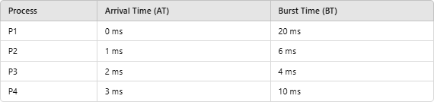

Execution Process
- Queue 1 Execution:
  - At time 0, P1 starts in Queue 1. After 4 ms, it is preempted and moved to Queue 2.
  - P2 arrives at time 1 and executes for 4 ms. It completes within its time quantum and exits.
  - P3 arrives at time 2 and executes for 4 ms. It completes and exits.
  - P4 arrives at time 3 and executes for 4 ms. It is preempted and moved to Queue 2.
- Queue 2 Execution:
  - P1 resumes execution for 8 ms but still does not complete. It is preempted and moved to Queue 3.
  - P2 resumes execution for 2 ms and completes.
  - P4 resumes execution for 6 ms and completes.
- Queue 3 Execution:
  - P1 executes in FCFS until completion (remaining 8 ms).

Gantt Chart

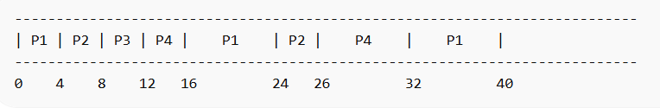

Process | AT | BT | CT | TAT (CT-AT) | WT (TAT-BT)
P1 | 0 | 20 | 40 | 40 | 20
P2 | 1 | 6 | 26 | 25 | 19
P3 | 2 | 4 | 12 | 10 | 6
P4 | 3 | 10 | 32 | 29 | 19

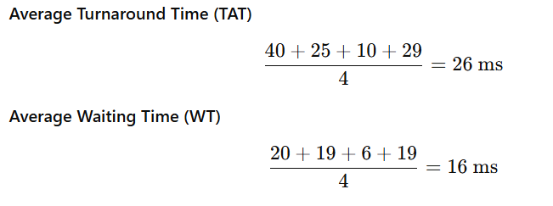

Advantages of Multilevel Feedback Queue Scheduling
- Adaptability: Dynamically adjusts process priorities based on behavior.
- Fairness: Shorter processes get higher priority, ensuring quick execution.
- Prevention of Starvation: Aging mechanism prevents indefinite delays for lower- priority processes.

Disadvantages of Multilevel Feedback Queue Scheduling
- Complexity: Managing multiple queues and dynamic process movement is challenging.
- Overhead: Frequent context switches increase CPU overhead.
- Parameter Sensitivity: Performance depends on the number of queues, time quanta, and aging mechanisms.
Multilevel Feedback Queue Scheduling is a versatile and efficient algorithm suitable for systems with diverse process requirements. Its adaptability and fairness make it ideal for multitasking environments, though careful configuration is necessary to balance performance and overhead.

The diagram below illustrates the structure of an MLFQ. A new process is initially added to Queue 1, and if it fails to complete its execution, it moves to Queue 2 and vice versa. Once a process completes its execution, it is removed from the queue. Additionally, the MLFQ can utilize boosting to elevate low-level processes to higher queues.
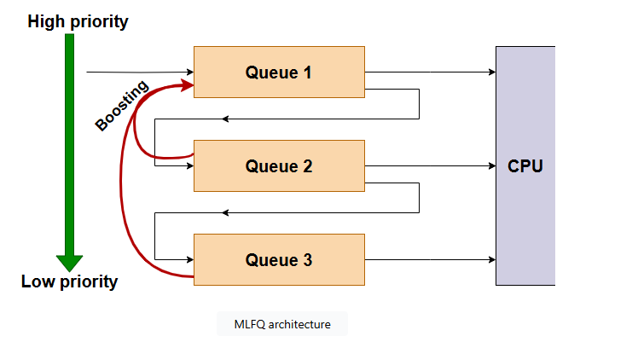

The steps involved in MLFQ scheduling when a process enters the system.
- When a process enters the system, it is initially assigned to the highest priority queue.
- The process can execute for a specific time quantum in its current queue.
- If the process completes within the time quantum, it is removed from the system.
- If the process does not complete within the time quantum, it is demoted to a lower priority queue and given a shorter time quantum.
- This promotion and demotion process continues based on the behavior of the processes.
- The high-priority queues take precedence over low-priority queues, allowing the latter processes to run only when high-priority queues are empty.
- The feedback mechanism allows processes to move between queues based on their execution behavior.
- The process continues until all processes are executed or terminated.

Example of MLFQ
There are various scheduling algorithms that can be applied to each queue, including FCFS, shortest remaining time, and round robin. Now, we will explore a multilevel feedback queue configuration consisting of three queues.
- Queue 1 (Q1) follows a round robin schedule with a time quantum of 8 milliseconds.
- Queue 2 (Q2) also uses a round robin schedule with a time quantum of 15 milliseconds.
- Finally, Queue 3 (Q3) utilizes a first come, first serve approach.
- Additionally, after 110 milliseconds, all processes will be boosted to Queue 1 for high-priority execution.

